Mini DC-DC Converter Step Down Module Adjustable Power Supply

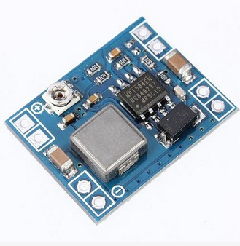
Real product is green color!

Description:
This is a DC power step down converter module that is ultra light weight, just the size of a finger nail.
This聽 Mini DC-DC Adjustable Step Down Converter is used for DIY mobile power, monitor power supply, buggies power, camera power supply, car power, communications equipment supply, there are a variety of size and weight for demanding situations (such as aviation models,etc.)
Specification:
Colour: Blue or Green (Delivery random)
Input voltage: 4.5V ~ 28V
Output voltage: 0.8V ~ 20V
Output current: rated current is 2A, maximum 3A (Additional heatsink is required)
Conversion efficiency: 96% (Highest)
Output ripple: < 30mV
Switching frequency: 1.5MHz (Highest) 1MHz (typically)
Work temperature: -45掳C to +85掳C
Potentiometer adjustment direction: clockwise (decrease), counter clock wise (decrease increase)
Dimension: 22 x 17 x 4mm (L x W x G)
Note:
This can't be used to step up voltage

